Lab EBS

**Creating and Attaching an EBS Volume**

* Launch a awslinux type resource
* Go to volume and check which availably zone volume has created
* EC2->Volume section

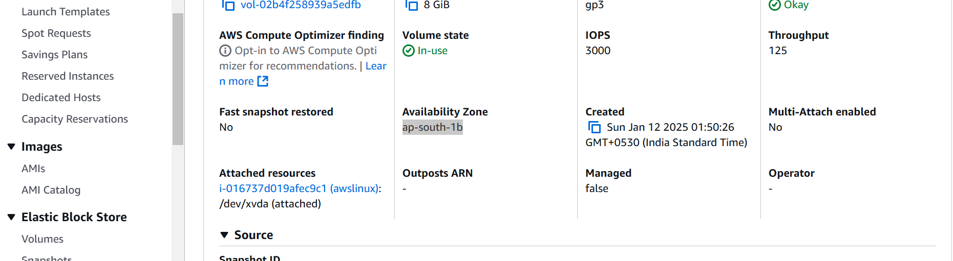

**1. Create an EBS Volume:**

* Go to the AWS Management Console.
* Navigate to the EC2 Dashboard.

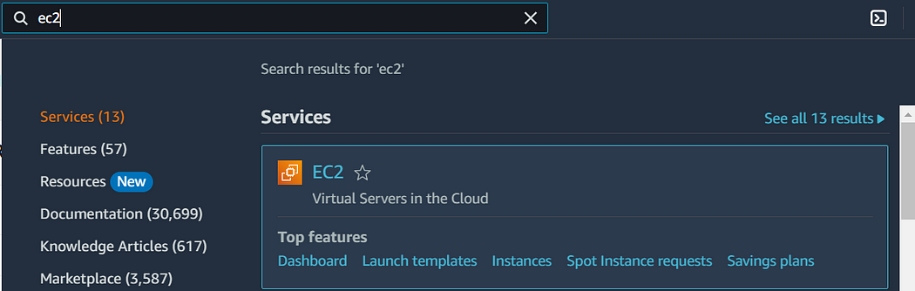

* Click on “Volumes” under “Elastic Block Store”.

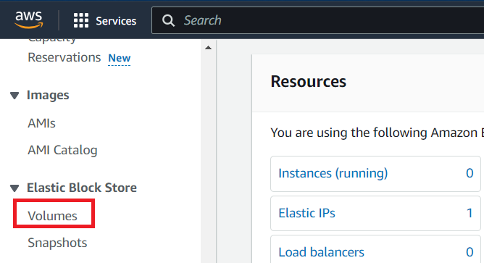

* Click “Create Volume”.

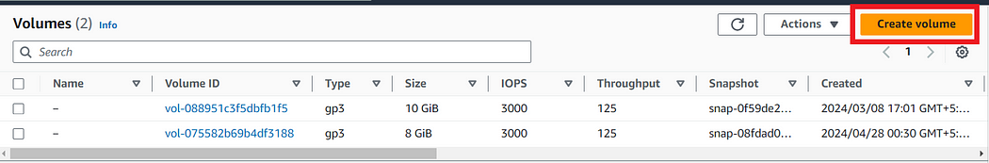

* Specify the volume type, size, and availability zone, then click “Create Volume”.

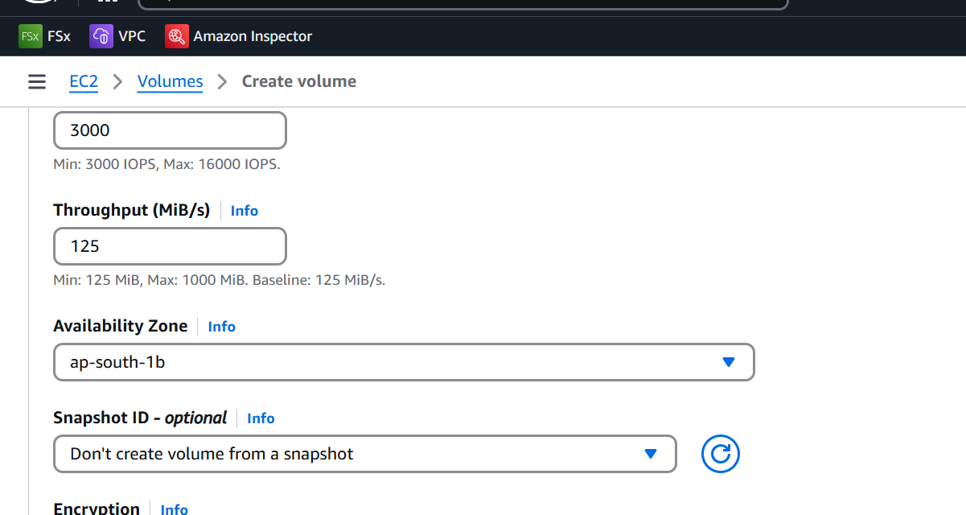

**2. Attach the EBS Volume to an Instance:**

* Select the newly created volume from the “Volumes” list.
* Click on “Actions” and select “Attach Volume”.

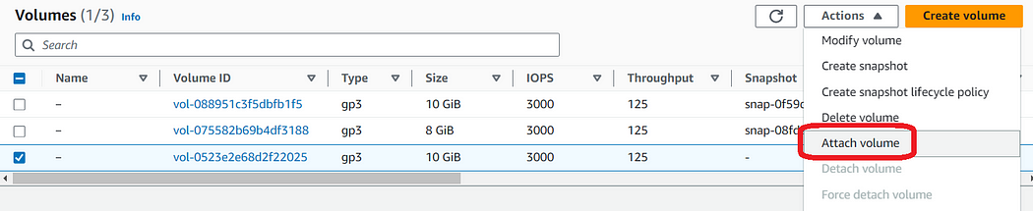

* Choose the instance to attach the volume to and specify the device name (e.g., /dev/sdf), then click “Attach Volume”.

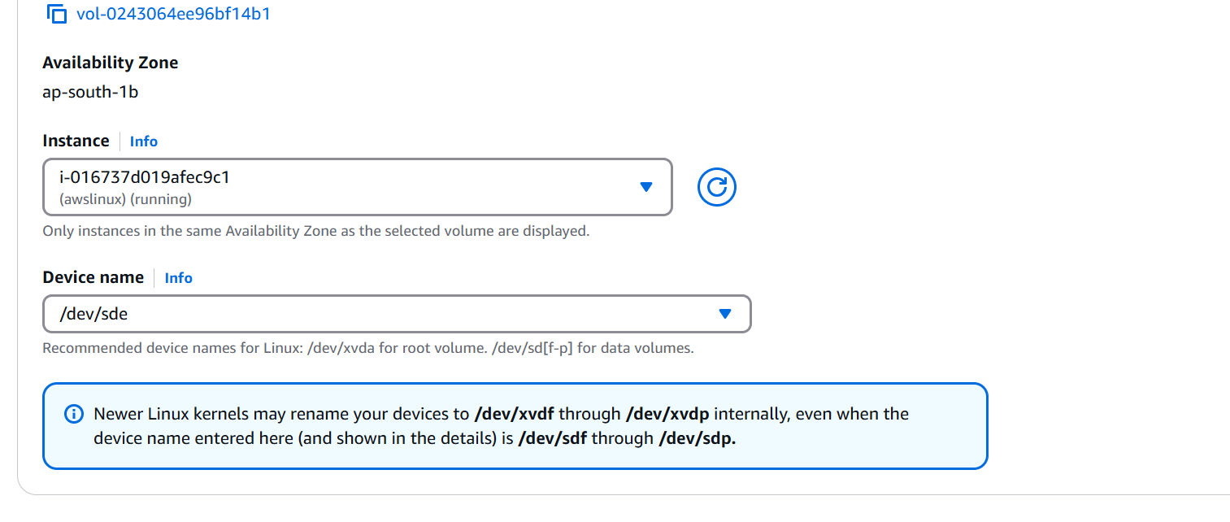

* Since the Volume is created in us-west-1a Availability zone, it will automatically detect all the instances in same availability zone. (EBS is AZ service).

**3. Formatting and Using the EBS Volume**

1. Connect to the EC2 Instance:

* Use SSH to connect to your EC2 instance.

2. Format the EBS Volume:

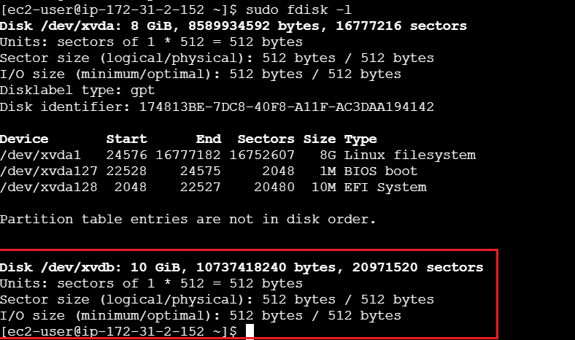

sudo mkfs.ext4 /dev/xvdb

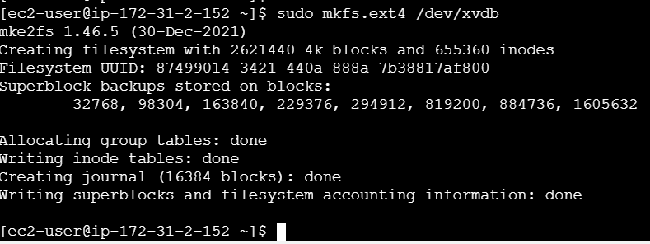

3. Mount the Volume:

sudo mkdir /data  
sudo mount /dev/xvdb /data

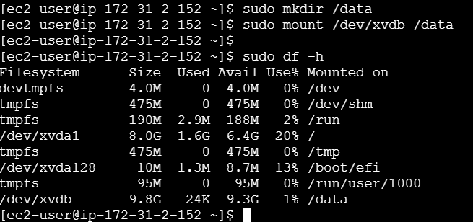

4. Store Data:

* You can now store data in the /data directory.

sudo cd /data

touch a

touch b

**4. Create a Snapshot:**

* Go to the “Volumes” section in the EC2 Dashboard.
* Select the volume, click “Actions”, and then “Create Snapshot”.
* Provide a description and click “Create Snapshot”.

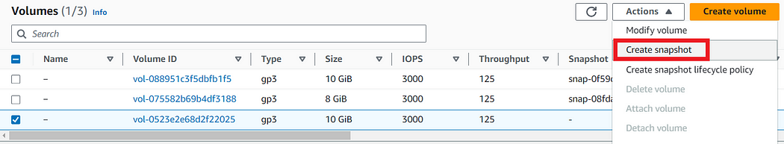

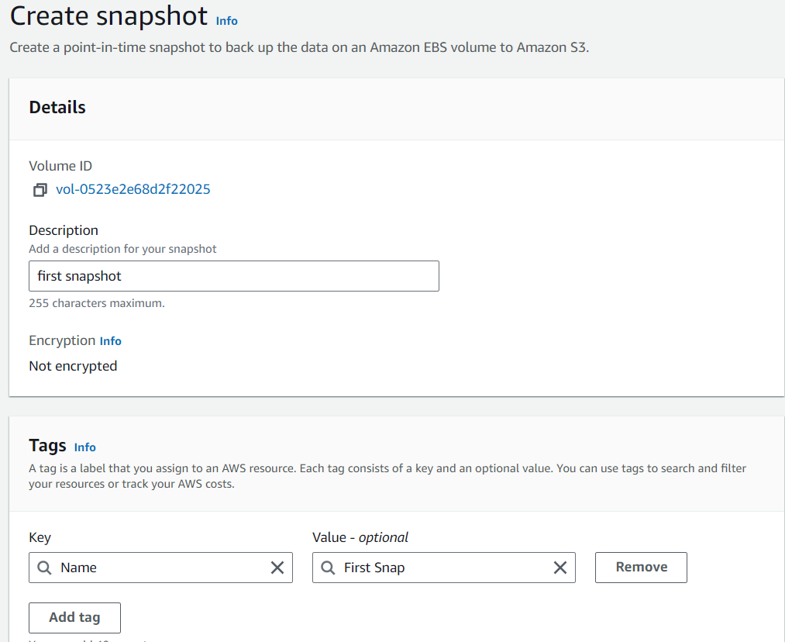

**5. Create a Volume from a Snapshot:**

* Go to the “Snapshots” section.
* Select the snapshot, click “Actions”, and then “Create Volume”.
* Specify the new volume details, including the availability zone, and click “Create Volume”.

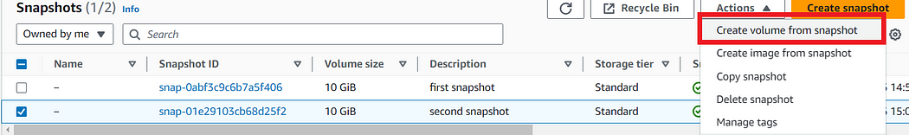

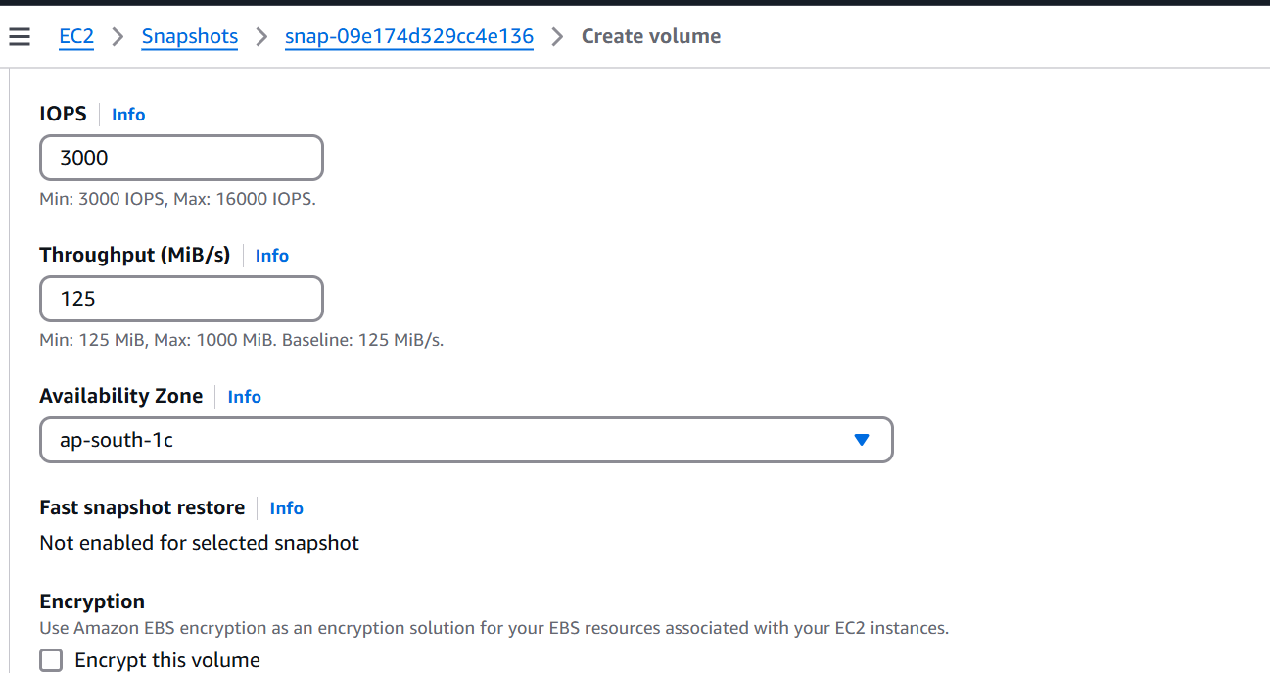

* Choose the Availability zone where you want to create that volume.
* We have choose ap-south-c

**6. Verification:**

* After this Attach this volume to other instance in us-south-c

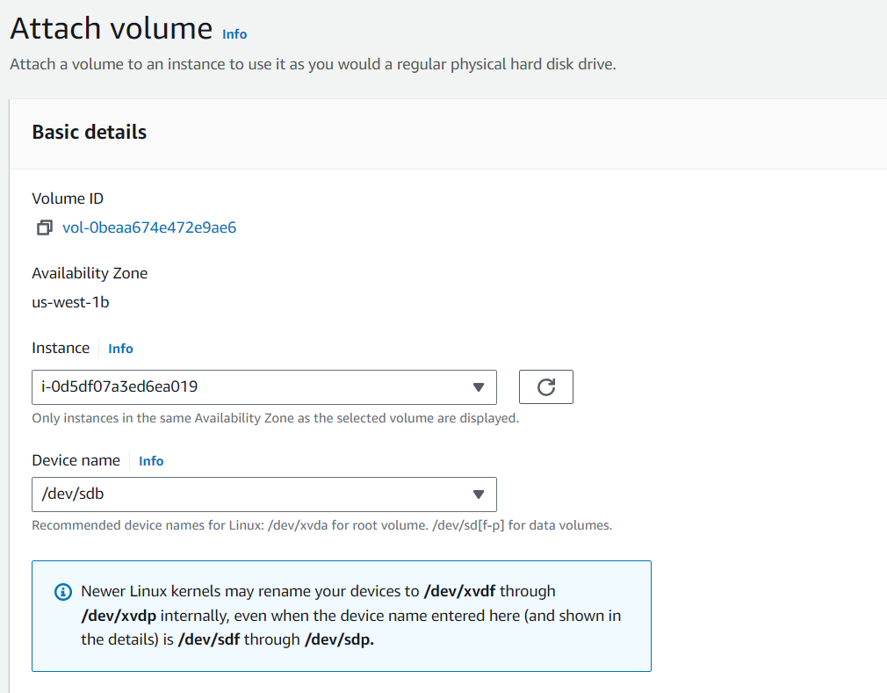

* Connect to that instance and mount the volume to /mydata folder.

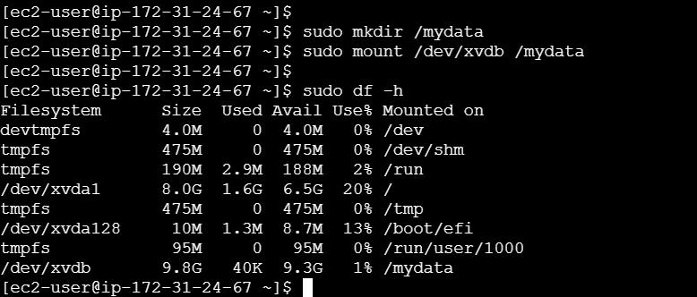

* And see whether the same data is present or not.
* Hence the verification is successful.